Software Requirements Specification

September 6, 2023

Online Bookstore (OB)

Zhuofan Huang

zhuang21@umd.edu

zhuang21

**Table of Contents**

**1.0. Description** 1

1.1. Overall Description 1

1.2. Detailed Description 1

**2.0. Use cases** 3

2.1 User use case 3

2.2 Administrator use case 5

**List of Figures**

Figure 1 – Basic Structure 1

**1.0. Description**

**1.1. Overall Description**

The OB application is a web-based platform that allows users to browse, search for and order books online. It serves as a convenient way for users to access a vast catalog of books with detailed information. Additionally, the OB application provides features to improve user interaction and ensure a pleasant shopping experience. Moreover, the OB system includes an administrative panel for managing book inventories, user accounts, and orders.

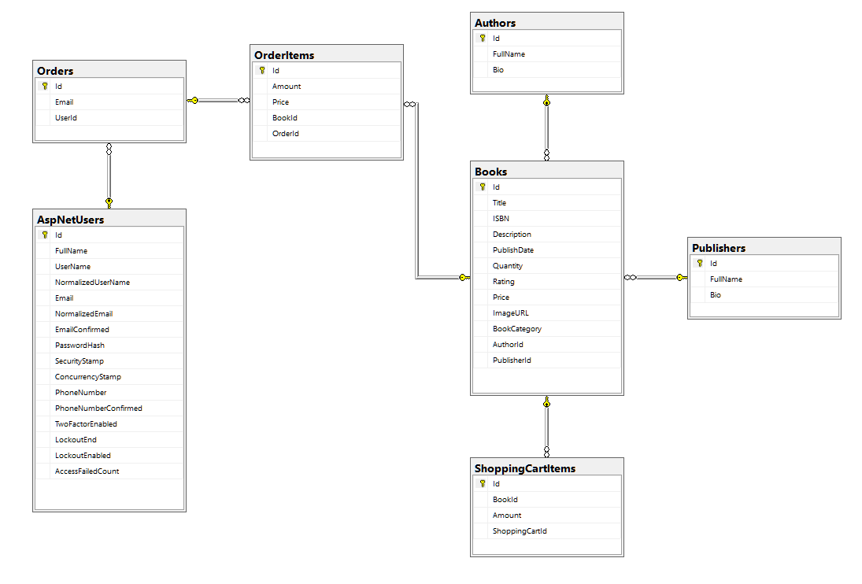

Figure 1 – Basic Structure

## 1.2. Detailed Description

The OB application allows user to create and manage accounts. User can create accounts with name, e-mail address and password.

The OB application have a book catalog. User can search for books with title or descriptions. Books can be displayed with details, including the title, author, cover image, description, average rating.

Users can add books to their shopping cart while browsing the catalog. The shopping cart displays the added books’ titles, quantity, each book’s price and the total price. Users can update the quantity of books and remove books in the cart. The OB application can calculate total price in the cart.

Users can use paypal to pay for the books online.

Users can also see details of authors and publishers. Users can see the list of authors and publishers.

The administrator can add books, edit books’ information, delete books, add authors, edit authors’ information, delete authors, add publishers, edit publishers’ information, delete publishers.

**2.0. Use cases**

## 2.1 User use case

Use case: **Book Search and Browsing**

**Brief Description**

A user wants to find a specific book or explore books based on their interests.

**Step-by-Step Description**

1.The user enters book title or descriptions in the search bar.

2.The system displays search results matching the query, including book titles and cover images.

3.The user selects a book from the search results.

4.The system presents the book's details, including the title, author, cover image, price, description, and average rating.

5.The user can add the book to their shopping cart if interested.

Use case: **Adding Books to the Shopping Cart**

**Brief Description**

A user wants to add one or more books to their shopping cart for purchase.

**Step-by-Step Description**

1.The user clicks on the "Add to Cart" button on the book's detail page.

2.The system adds the selected book to the user's shopping cart.

3.The system displays a notification confirming the successful addition of the book to the cart.

Use case: **Check out**

**Brief Description**

A user wants to check out shopping cart.

**Step-by-Step Description**

1.The user clicks on the "Shopping Cart" button on the page.

2.The system shows shopping cart page with books, amounts, subtotal prices, and total price.

3.The user click on check out button and there is a payment pop-up.

4.The user login to paypal account, choose payment method and finish check out.

Use case: **See order details**

**Brief Description**

A user wants to see order details.

**Step-by-Step Description**

1.The user visits the online bookstore website.

2.The user clicks on the "Sign in" button.

3.The user inputs username and password.

4.The user successfully logged in.

5.The user clicks button with username and see a dropdown table with order button.

6.The user clicks “Order” button and system shows list of user’s orders with order ids, items from each orders, and total prices for each orders.

## 2.2 Administrator use case

Use case: **Edit Book Information**

**Brief Description**

The administrator wants to edit a book’s information.

**Step-by-Step Description**

1.The administrator logs in with admin account.

2.The administrator use search bar to search for the book need to be updated.

3.The administrator clicks on show details button, and see the book’s details.

4.The administrator can click on edit button and edit the book’s details, such as title, author, description, cover image, and price, etc.

Use case: **Delete Book**

**Brief Description**

The administrator wants to delete a specific book.

**Step-by-Step Description**

1.The administrator logs in with admin account.

2.The administrator use search bar to search for the book need to be updated.

3.The administrator clicks on show details button, and see the book’s details.

4.The administrator can click on edit button and edit the book’s details, such as title, author, description, cover image, and price, etc.

5.The administrator can click on delete button on the detail page to delete the book.

6.The administrator can mark books as obsolete or out of stock, removing them from the available inventory.

7.The system updates the book inventory accordingly, reflecting the changes made by the administrator.

**3.0. Misuse Cases**

Misuse case: **Hash Cracking**

**Description**

The attacker can use hash cracking application to crack users’ passwords because the application uses asp.net identity’s default hasher to hash password.

Misuse case: **Brute-force cracking password**

**Description**

The attacker can use brute-force to crack users’ password, because the application doesn’t have log in attempts’ limitation.

Misuse case: **Brute-force cracking password**

**Description**

The attacker can use brute-force to crack users’ password, because the application doesn’t have log in attempts’ limitation.

Misuse case: **Hijacking sessions**

**Description**

The attacker can hijack other users’ sessions. The application doesn’t have an automatic log out system, attacker can steal the user’s session identifier to steal user’s identity.